CS 255 System Design Document Template

UML Diagrams

UML Use Case Diagram
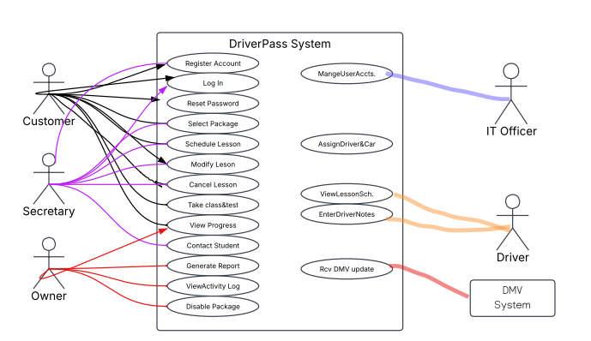
This diagram shows who uses DriverPass and what each person can do. Customers register, log in, choose a package, and schedule, change or cancel two-hour lessons. The secretary does the same for customers who call. The owner views reports and the activity log and can disable a package. The IT officer manages user accounts, including password resets. Drivers view their lesson schedule and enter notes. The DMV system sends updates.

UML Activity Diagrams
Schedule Lesson:
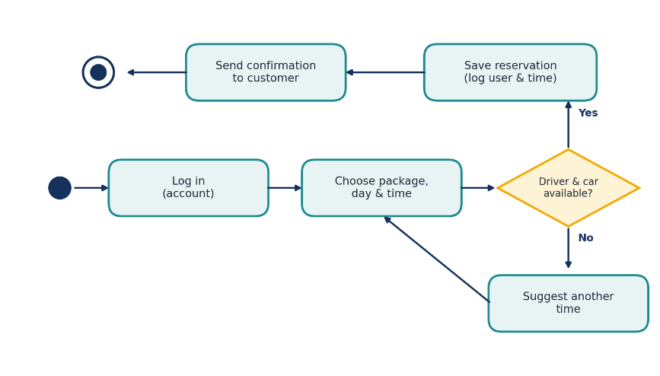
A customer logs in, picks a package, day, and time, and the system checks that a driver and car
are free. If not, the customer picks another time. If so, the reservation is saved with who made
it and when, and confirmation is sent.

Activity Diagram 2: Reset Password
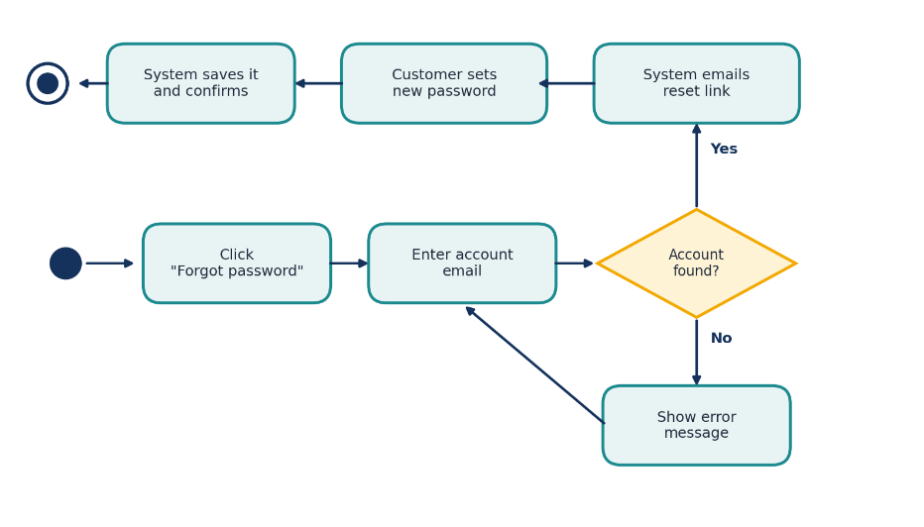
A customer who forgets a password asks for a reset, enters their account email, and the system emails a reset link if the account exists. The customer sets a new password, and the system saves it and confirms.

UML Sequence Diagram
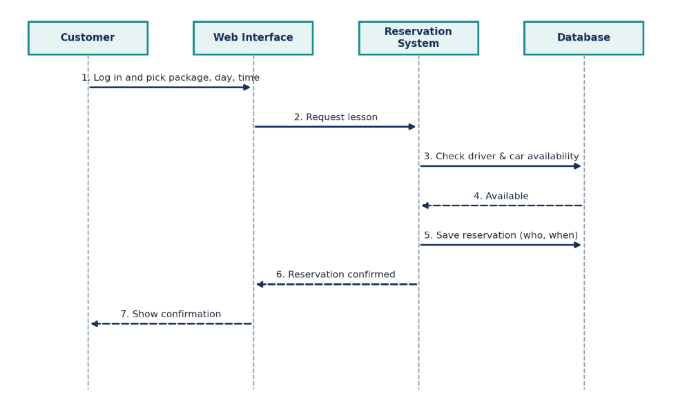
This sequence diagram shows the Schedule Lesson use case. The customer sends a request
through the web interface to the reservation system, which checks availability in the database,
saves the reservation and returns a confirmation.

UML Class Diagram
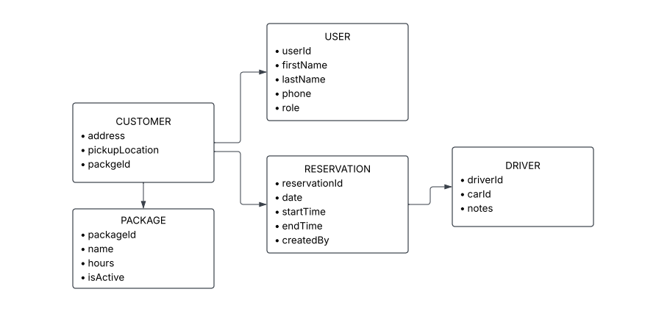
The main classes are User (with Customer and Employee types), Package, Reservation, Driver /
Car, OnlineTest and ActivityLog. Reservation stores who created and last modified it so the
owner can print an activity report. Package includes an active flag so the owner can disable it.

Technical Requirements
Hardware
• Cloud-hosted servers provided by the hosting company, so DriverPass does not buy or
maintain its own servers
• Office computers for the owner, secretary and IT officer, and any phone, tablet or
computer for customers and drivers with a web browser and internet

Software
• A web application that runs in any modern browser, with separate screens for each role
• A database to store accounts, packages, reservations, test results, driver notes and the
activity log
• Email service for confirmations and password reset links, and report export so the
owner can open data in Excel
• Connection to the DMV system to receive updates and send a notification when rules,
policies or sample questions change

Tools
• Lucidchart for UML diagrams, and testing tools to check the system before delivery

Infrastructure
• Cloud hosting with automatic backups, security updates and a secure (HTTPS)
connection
• Role-based access so each user sees only what they need, and the IT officer can reset
passwords and block accounts
• Data can be changed only while online, to avoid duplicate records on different servers
• Secure storage of customer information and payment details
I used Claude to help me create the activity diagrams and the technical requirements. I made the case and class diagrams myself.

REFERENCE
Anthropic. (2026), Claude (Opus 5.5 version) [Large language model]. https://claude.ai

